Chapter 2
“To what extent is the justice system fair and equitable for youth?”

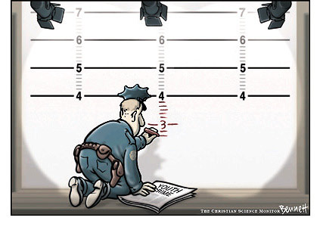

Social Studies 9

1) Why do you think children younger than 12 are treated differently than children 12-17 years old?

2) Why do you think youth 12-17 are not treated the same way as adults?

3) What special considerations must be made when choosing appropriate consequences and sentences for youth crime?

Activity 3: Use your textbook (Ch. 2 pages 56-87) to help you answer the following questions:

1. What does the term fair and equitable mean?

__________________________________________________________________________

__________________________________________________________________________

2. What is Canada's justice system and what is it trying to do?

__________________________________________________________________________

__________________________________________________________________________

3. What is one of the fundamental principles of justice in Canada and other democratic countries?

__________________________________________________________________________

4. What would happen to society without justice?

__________________________________________________________________________

5. If you are arrested what rights do you have?

__________________________________________________________________________

__________________________________________________________________________

6. What is the role of a Youth Justice Committee?

__________________________________________________________________________

__________________________________________________________________________

7. What five aspects of the YCJA are mentioned on page 64?

__________________________________________________________________________

__________________________________________________________________________

__________________________________________________________________________

__________________________________________________________________________

__________________________________________________________________________

8. Before the Youth Criminal Justice Act every young person who broke the law was charged and went to court. What problems did this create?

__________________________________________________________________________

__________________________________________________________________________

__________________________________________________________________________

9. Why does Anne McLellan say that young people, up to a certain age, should not be treated as adults?

__________________________________________________________________________

__________________________________________________________________________

10. According to Anne McLellan how can young people get involved with youth justice?

__________________________________________________________________________

__________________________________________________________________________

11. What factors determine the consequences Young Offenders face? (p.68)

__________________________________________________________________________

__________________________________________________________________________

__________________________________________________________________________

20. What is a jury?

__________________________________________________________________________

21. What must you do if chosen to serve on a jury?

__________________________________________________________________________

__________________________________________________________________________

22. How can some people be excused from jury duty?

__________________________________________________________________________

23. Define the following terms

Defense - __________________________________________________________________

Prosecution - _______________________________________________________________

Sequester - _________________________________________________________________

24. Why is the accused shown to all prospective jury members?

__________________________________________________________________________

25. Who decides which prospective jurors will make up the final jury?

__________________________________________________________________________

26. In what ways does the court try to ensure that a sequestered jury does not have contact with the outside world?

__________________________________________________________________________

__________________________________________________________________________

__________________________________________________________________________

27. Does a jury decision have to be unanimous? ___________________________________

28. Will you be paid for time taken off of work to serve on a jury? _____________________

28. What are justice advocacy groups and what role do they serve in the justice system?

__________________________________________________________________________

__________________________________________________________________________

29. How are the two major citizen-led organizations John Howard Society and Elizabeth Fry Society involved in the justice system? In what way are the Elizabeth Fry and John Howard Societies different?

__________________________________________________________________________

__________________________________________________________________________

__________________________________________________________________________

__________________________________________________________________________

__________________________________________________________________________

Youth Crime in Canada: An Overview
- Answer the following questions about youth crime in Canada by ticking the  column if the statement is true and the 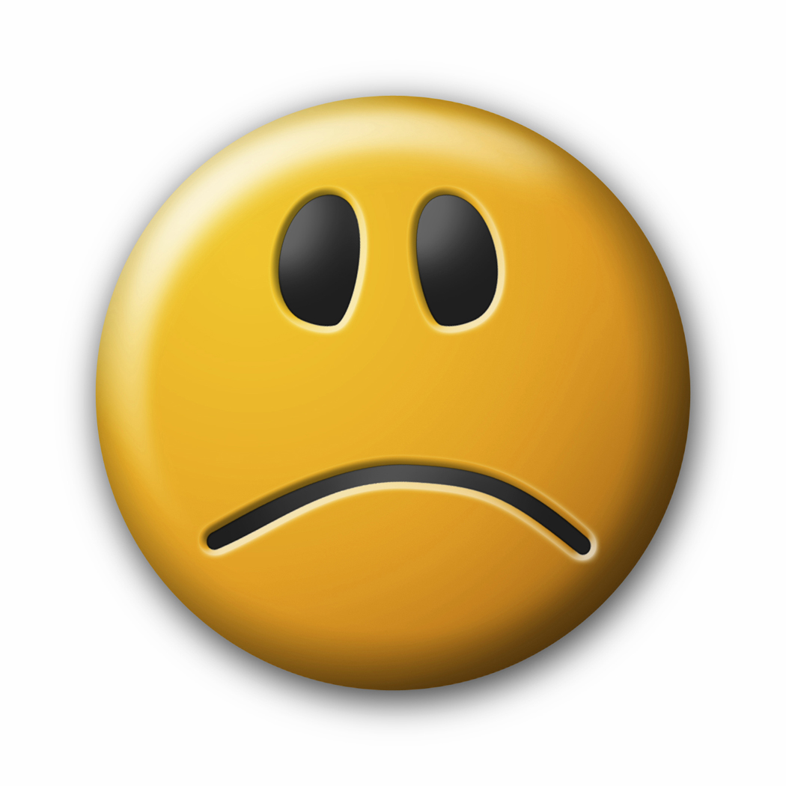 column if the statement is false.
- Flip through chapter 2 to find the answers…

Statements about the YCJA:
- Young offenders are treated differently than adult offenders
- The Youth Criminal Justice Act (YCJA) is the law that defines the consequences young people face for criminal offenses
- An 11 year old cannot be charged with a criminal offence
- A 15 year old can be given an adult sentence
- The names of young offenders cannot be published in the newspaper
- Young offenders do not get criminal records
- Two youths of the same age who commit the exact same offence may face different consequences
- Violent crime is dealt with more seriously than non-violent crimes
- Police do not need to charge first time young offenders
- The YCJA attempts to deal with the underlying causes of crime
- The YCJA tries to reintegrate young offenders back into society
- Young offenders are deemed to have a “reduced moral culpability”
- Youth crime in Canada is on the rise
- Most youth crime in Canada involves violence
- Youth that commit serious crimes often get off with a “slap on the wrist”
- The YCJA ignores victims of crime
- Aboriginal young offenders in Canada are more likely to get a tougher sentence than a non-Aboriginal young offender for the same offence
- Most young offenders only get in trouble with the law once
- A young offender who goes to trial cannot choose to be tried by a jury
- Do you think the law is tough enough on young offenders?

Reading Political Cartoons – CH. 2

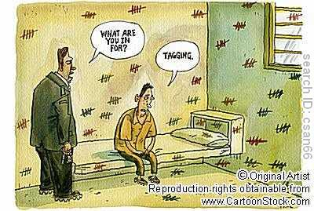
What situation does the cartoon show? TOPIC
_______________________________________________________________________________________________________________________________________________________________________________________________________________
What symbols does the cartoon use?
_______________________________________________________________________________________________________________________________________________________________________________________________________________

What’s the intended message? ISSUE/PROBLEM & AUTHOR’s Response
__________________________________________________________________________________________________________________________________________
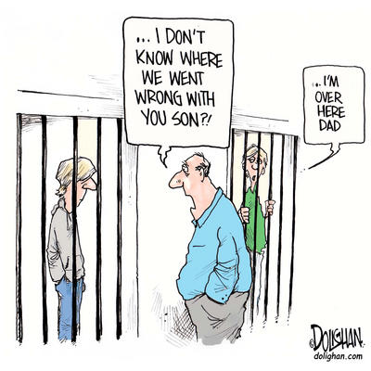

What situation does the cartoon show? TOPIC
_______________________________________________________________________________________________________________________________________________________________________________________________________________________________________
What symbols does the cartoon use?
_______________________________________________________________________________________________________________________________________________________________________________________________________________________________________

What’s the intended message? ISSUE/PROBLEM & AUTHOR’s Response
__________________________________________________________________________________________________________________________________________________________________________________________________________________________________________

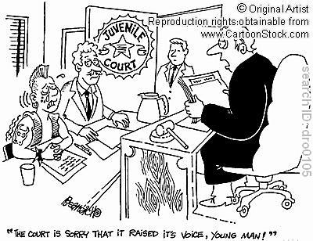

What situation does the cartoon show? TOPIC
__________________________________________________________________________________________________________________________________________________________________________________________________________________________________________
What symbols does the cartoon use?
__________________________________________________________________________________________________________________________________________________________________________________________________________________________________________

What’s the intended message? ISSUE/PROBLEM & AUTHOR’s Response
__________________________________________________________________________________________________________________________________________________________________________________________________________________________________________

Is the YCJA Fair and Equitable?
Complete the following table

When developing a consequence for a youth offender the YJCA may focus on the following issues. Are these issues fair or not fair to bring into the discussion of the consequences of the youths actions?

YCJA | FAIR – describe how so | NOT FAIR –describe how not
Consideration of the youth’s background including, ethnicity, age, culture, language, etc

Consideration of circumstances before the crime was committed

Involvement of Community Supports/Advocacy Groups

Consideration of whether or not the offender holds a Previous Record.

Consideration of the danger the public may face

An attempt to reintegrate the youth back into society.

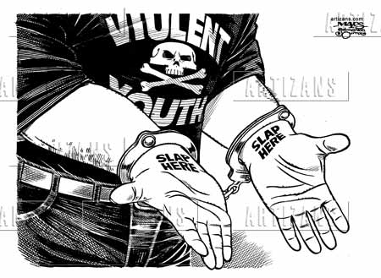
Is the YCJA Fair and Equitable?

Write a two paragraph response to answer the question above using the following structure:

Paragraph 1
- Identify the point of view expressed in the cartoon in as much detail as you can
- Explain why some people might agree with this point of view (include supporting evidence)
- Explain why some people might disagree with this point of view (include supporting evidence)

Paragraph 2
- Answer the question (to what extent do you agree or disagree with the point of view expressed in the political cartoon?)
- Explain your answer
- Defend your position

Write your response below. You may choose to do a draft on a separate sheet of paper first.

Assessment:

 | Knowledge | Reflection & Application
4 | - Student demonstrated excellent knowledge of the subject being studied. | - Responses make connections, and/or offer insightful interpretations.  - Student was able to accurately and thoughtfully apply the material.
3 | - Student demonstrated good knowledge with only minimal errors or omissions of the subject being studied. | - Responses may make some connections, however, may not be applicable in all situations or examples.  - Student was able to apply material.
2 | - Student demonstrated minimal knowledge and/or there are many errors or omissions of the subject being studied. | - Accurate responses are limited to literal interpretations. There is little attempt to make connections. The student is unable to provide examples and/or the student struggled to apply material.
1 | - Student demonstrated little to no knowledge and/or there were glaring errors and many omissions. | - There are limited to no responses or connections made. There may also have been no attempt to apply material.

TOTAL: ______ /10 Comments:

